WAYS TO EVALUATE REGRESSION MODEL
Mean Squared Error (MSE)
Mean Squared Error (MSE) of an estimator measures the average of the squares of the errors — that is, the average squared
difference between the estimated values and the actual value.
The MSE is a measure of the quality of an estimator — it is always non-negative, and values closer to zero are better.
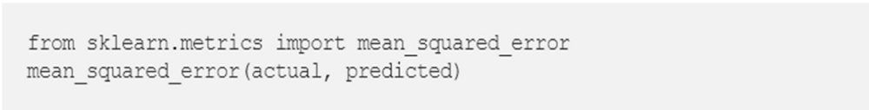
Root Mean Squared Error (RMSE)
In statistical modeling and particularly regression analyses, a common way of measuring the quality of the fit of the model is the RMSE (also called Root Mean Square Deviation), given by where yi is the ith observation of y and ŷ the predicted y value given the model. If the predicted responses are very close to the true responses the RMSE will be small.
If the predicted and true responses differ substantially — at least for some observations — the RMSE will be large.
A value of zero would indicate a perfect fit to the data.
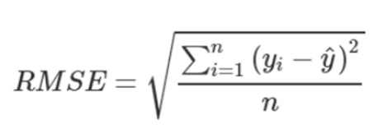
Since the RMSE is measured on the same scale, with the same units as y, one can expect 68% of the y values to be within 1
RMSE — given the data is normally distributed.

Relative Squared Error (RSE)
The relative squared error (RSE) is relative to what it would have been if a simple predictor had been used.
More specifically, this simple predictor is just the average of the actual values.
Thus, the relative squared error takes the total squared error and normalizes it by dividing by the total squared error of the
simple predictor.
It can be compared between models whose errors are measured in the different units.
Mathematically, the relative squared error, Ei of an individual model i is evaluated by the equation:
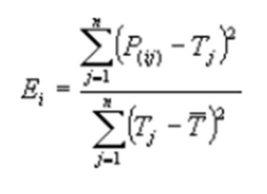
Where P(ij) is the value predicted by the individual model i for record j (out of n records)
Tj is the target value for record j
Tbar is given by the formula
For a perfect fit, the numerator is equal to 0 and Ei = 0.
So, the Ei index ranges from 0 to infinity, with 0 corresponding to the ideal.

Coefficient of Determination (R2)
R-squared (R2) is a statistical measure that represents the proportion of the variance for a dependent variable that’s explained
by an independent variable or variables in a regression model.
R-squared explains to what extent the variance of one variable explains the variance of the second variable.
So, if the R2 of a model is 0.50, then approximately half of the observed variation can be explained by the model’s inputs.
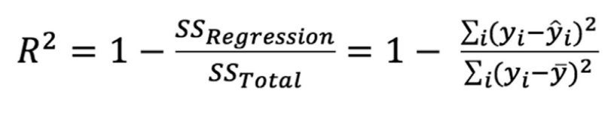
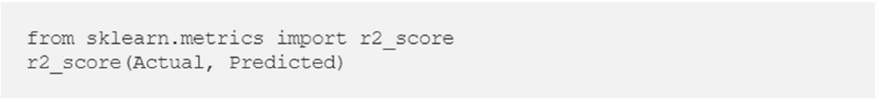
It can be proved using Calculus that the cost function is convex function, below is the plot of cost function vs if in the
equation we have only one parameter

Correct: Simultaneous update Incorrect:
